**Installation of Dependencies**

To navigate between screens using React Navigation we need to add react-navigation and other supporting dependencies.

To install the dependencies open the terminal and jump into your project

1. Install react-navigation

npm **install** @react-navigation/**native** –save

2. Other supporting libraries react-native-gesture-handler, react-native-reanimated, react-native-screens and react-native-safe-area-context and @react-native-community/masked-view

npm **install** react-**native**-reanimated react-**native**-gesture-**handler** react-**native**-screens react-**native**-**safe**-area-**context** @react-**native**-community/masked-**view** –save

3. For the Stack Navigator install

**npm** **install** @**react**-**navigation**/**stack** –save

To finalize the installation of react-native-gesture-handler, add the following at the top (make sure it’s at the top and there’s nothing else before it) of your entry files, such as index.js or App.js:

**import** 'react-native-gesture-handler';

**Directory Structure for Example**

To start with this Example you need to create a directory named **pages** in your project and three files under it with the name **FirstPage.js**, **SecondPage.js**, and **ThirdPage.js**

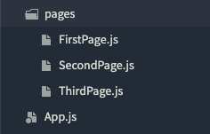

## Code

Now Open App.js in any code editor and replace the code with the following code.

### App.js

// Navigate Between Screens using React Navigation in React Native //

// https://aboutreact.com/react-native-stack-navigation //

import 'react-native-gesture-handler';

import * as React from 'react';

import { Button, View, Text } from 'react-native';

import { NavigationContainer } from '@react-navigation/native';

import { createStackNavigator } from '@react-navigation/stack';

import FirstPage from './pages/FirstPage';

import SecondPage from './pages/SecondPage';

import ThirdPage from './pages/ThirdPage';

const Stack = createStackNavigator();

function App() {

return (

<NavigationContainer>

<Stack.Navigator initialRouteName="FirstPage">

<Stack.Screen

name="FirstPage"

component={FirstPage}

options={{

title: 'First Page', //Set Header Title

headerStyle: {

backgroundColor: '#f4511e', //Set Header color

},

headerTintColor: '#fff', //Set Header text color

headerTitleStyle: {

fontWeight: 'bold', //Set Header text style

},

}}

/>

<Stack.Screen

name="SecondPage"

component={SecondPage}

options={{

title: 'Second Page', //Set Header Title

headerStyle: {

backgroundColor: '#f4511e', //Set Header color

},

headerTintColor: '#fff', //Set Header text color

headerTitleStyle: {

fontWeight: 'bold', //Set Header text style

},

}}

/>

<Stack.Screen

name="ThirdPage"

component={ThirdPage}

options={{

title: 'Third Page', //Set Header Title

headerStyle: {

backgroundColor: '#f4511e', //Set Header color

},

headerTintColor: '#fff', //Set Header text color

headerTitleStyle: {

fontWeight: 'bold', //Set Header text style

},

}}

/>

</Stack.Navigator>

</NavigationContainer>

);

}

export default App;

### pages/FirstPage.js

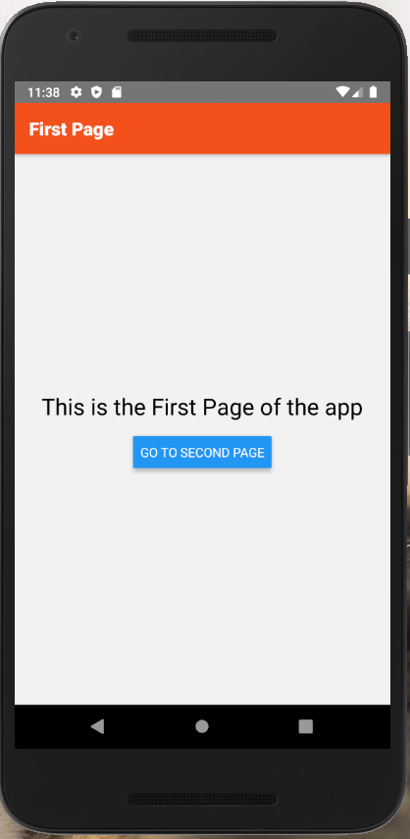

// Navigate Between Screens using React Navigation in React Native //

// https://aboutreact.com/react-native-stack-navigation //

import * as React from 'react';

import { Button, View, Text, SafeAreaView } from 'react-native';

const FirstPage = ({ navigation }) => {

return (

<SafeAreaView style={{ flex: 1 }}>

<View style={{ flex: 1 , padding: 16}}>

<View

style={{

flex: 1,

alignItems: 'center',

justifyContent: 'center',

}}>

<Text

style={{

fontSize: 25,

textAlign: 'center',

marginBottom: 16

}}>

This is the First Page of the app

</Text>

<Button

onPress={() => navigation.navigate('SecondPage')}

title="Go to Second Page"

/>

</View>

</View>

</SafeAreaView>

);

}

export default FirstPage;

### pages/SecondPage.js

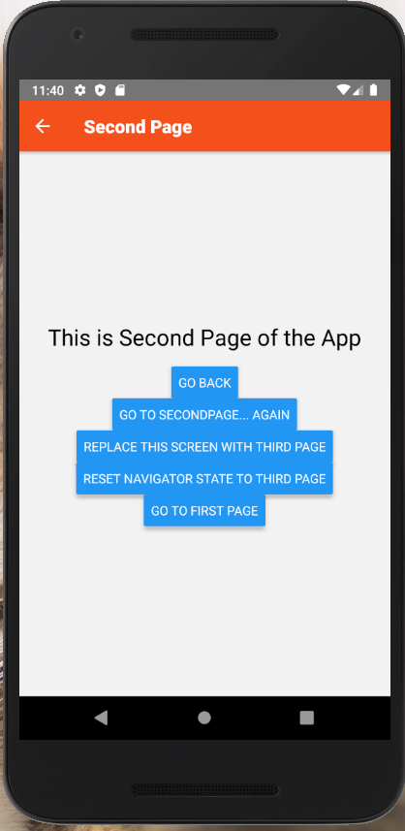

// Navigate Between Screens using React Navigation in React Native //

// https://aboutreact.com/react-native-stack-navigation //

import * as React from 'react';

import { Button, View, Text, SafeAreaView } from 'react-native';

const ThirdPage = ({navigation }) => {

return (

<SafeAreaView style={{ flex: 1 }}>

<View style={{ flex: 1, padding: 16 }}>

<View

style={{

flex: 1,

alignItems: 'center',

justifyContent: 'center',

}}>

<Text

style={{

fontSize: 25,

textAlign: 'center',

marginBottom: 16

}}>

This is Third Page of the App {'\n'}

</Text>

<Button

onPress={() => navigation.navigate('SecondPage')}

title="Go to Second Page"

/>

<Button

title="Replace this screen with First Page"

onPress={() =>

navigation.replace('FirstPage', { someParam: 'Param'})

}

/>

<Button

title="Reset navigator to First Page"

onPress={() =>

navigation.reset({

index: 0,

routes: [

{

name: 'FirstPage',

params: { someParam: 'reset' },

},

],

})

}

/>

</View>

</View>

</SafeAreaView>

);

}

export default ThirdPage;

### pages/ThirdPage.js

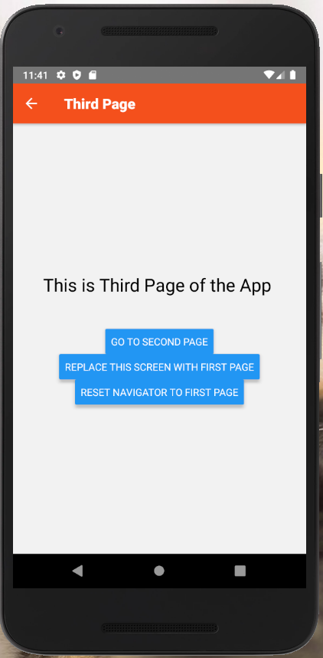

// Navigate Between Screens using React Navigation in React Native //

// https://aboutreact.com/react-native-stack-navigation //

import * as React from 'react';

import { Button, View, Text, SafeAreaView } from 'react-native';

const ThirdPage = ({navigation }) => {

return (

<SafeAreaView style={{ flex: 1 }}>

<View style={{ flex: 1, padding: 16 }}>

<View

style={{

flex: 1,

alignItems: 'center',

justifyContent: 'center',

}}>

<Text

style={{

fontSize: 25,

textAlign: 'center',

marginBottom: 16

}}>

This is Third Page of the App {'\n'}

</Text>

<Button

onPress={() => navigation.navigate('SecondPage')}

title="Go to Second Page"

/>

<Button

title="Replace this screen with First Page"

onPress={() =>

navigation.replace('FirstPage', { someParam: 'Param'})

}

/>

<Button

title="Reset navigator to First Page"

onPress={() =>

navigation.reset({

index: 0,

routes: [

{

name: 'FirstPage',

params: { someParam: 'reset' },

},

],

})

}

/>

</View>

</View>

</SafeAreaView>

);

}

export default ThirdPage;